**PSG College of Technology, Coimbatore-04**

**Department of Applied mathematics and Computational Sciences**

**20XC28 – Python Programming Lab**

**Problem Sheet – I**

1. Write a program that displays the following information.

• Your name

• Your address, with city, state, and ZIP

• Your telephone number

• Your college major

1. Given an airplane’s acceleration a and take-off speed v, you can compute the minimum runway length needed for an airplane to take off using the following formula:

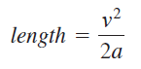

Write a program that prompts the user to enter v in meters/second (m/s) and the acceleration a in meters/second squared and displays the minimum runway length. Here is a sample run:



1. Write a program that prompts the user to enter the three points (x1, y1), (x2, y2), and (x3, y3) of a triangle and displays its area. The formula for computing the area of a triangle is

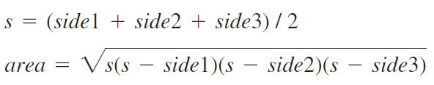

Here is a sample run:

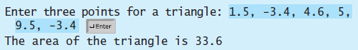

1. Consider the following circuit.

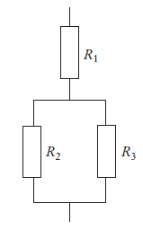

Write a program that reads the resistances of the three resistors and computes the total resistance, using Ohm’s law.

1. The US Census Bureau projects population based on the following assumptions.

One birth every 7 seconds

One death every 13 seconds

One new immigrant every 45 seconds

Write a program to display the population for each of the next five years. Assume the current population is 312032486 and one year has 365 days.

1. Write a program that will convert U.S. dollar amounts to Japanese Yen and to Euros. To get the most up-to-date exchange rates, search the Internet using the term “currency exchange rate”. If you cannot find the most recent exchange rates, use the following:

1 Dollar = 113.22 Yen

1 Dollar = 0.6936 Euros

Format your currency amounts in fixed-point notation, with two decimal places of precision, and be sure the decimal point is always displayed.

1. Suppose you want to deposit a certain amount of money into a savings account with a fixed annual interest rate. What amount do you need to deposit in order to have Rs. 5,000 in the account after three years? The initial deposit amount can be obtained using the following formula:

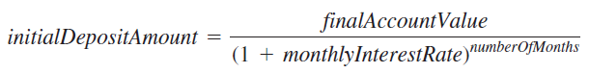

Write a program that prompts the user to enter final account value, annual interest rate in percent, and the number of years, and displays the initial deposit amount.

1. Write a program that will ask the user to enter the amount of a purchase. The program should then compute the state and county sales tax. Assume the state sales tax is 4 percent and the county sales tax is 2 percent. The program should display the amount of the purchase, the state sales tax, the county sales tax, the total sales tax, and the total of the sale (which is the sum of the amount of purchase plus the total sales tax).
2. Write a program that calculates the total amount of a meal purchased at a restaurant. The program should ask the user to enter the charge for the food, and then calculate the amount of a 15 percent tip and 7 percent sales tax. Display each of these amounts and the total.
3. Body mass index (BMI) is a measure of health based on weight. It can be calculated by taking your weight in kilograms and dividing it by the square of your height in meters. Write a program that prompts the user to enter a weight in pounds and height in inches and displays the BMI. Note that one pound is 0.45359237 kilograms and one inch is 0.0254 meters.

Here is a sample run:

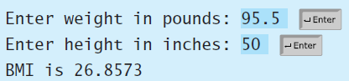

1. Last month Joe purchased some stock in Acme Software, Inc. Here are the details of the purchase.
   * The number of shares that Joe purchased was 1,000
   * When Joe purchased the stock, he paid Rs. 32.87 per share

* Joe paid his stockbroker a commission that amounted to 2 percent of the amount he paid for the stock

Two weeks later Joe sold the stock. Here are the details of the sale:

* The number of shares that Joe sold was 1,000
* He sold the stock for Rs. 33.92 per share
* He paid his stockbroker another commission that amounted to 2 percent of the amount he received for the stock

Write a program that displays the following information:

* The amount of money Joe paid for the stock.
* The amount of commission Joe paid his broker when he bought the stock.
* The amount that Joe sold the stock for.
* The amount of commission Joe paid his broker when he sold the stock.
* Display the amount of money that Joe had left when he sold the stock and paid his broker (both times). If this amount is positive, then Joe made a profit. If the amount is negative, then Joe lost money

1. Write a program that reads the following information and prints a payroll statement.

Employee’s name (e.g., Smith)

Number of hours worked in a week (e.g., 10)

Hourly pay rate (e.g., 9.75)

Federal tax withholding rate (e.g., 20%)

State tax withholding rate (e.g., 9%)

A sample run is shown below:

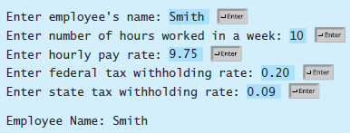

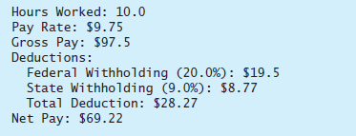

1. Write a program that prompts the user to enter two points (x1, y1) and (x2, y2) and displays their distance between them. The formula for computing the distance is



1. Write a program that prompts the user to enter the distance to drive, the fuel efficiency of the car in miles per gallon, and the price per gallon, and displays the cost of the trip. Here is a sample run

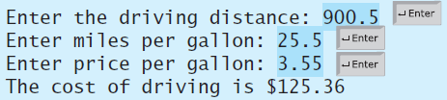

1. A movie theater only keeps a percentage of the revenue earned from ticket sales. The remainder goes to the movie distributor. Write a program that calculates a theater’s gross and net box office profit for a night. The program should ask for the name of the movie, and how many adult and child tickets were sold. (The price of an adult ticket is $6.00 and a child’s ticket is $3.00.) It should display a report similar to

